**

**Geldmaat**

**Deactivate Cash Point Workflow**

www.amplifiuk.com

+44 (0) 1926 911820

Third Floor, Marlborough House

48 Holly Walk, Leamington Spa

CV32 4XP, United Kingdom

### 1. [Go to Log in](https://certification.dev.mdm.geldmaat.nl/login.do)

### 2. Type "ChangeDesk"

### 3. Type password

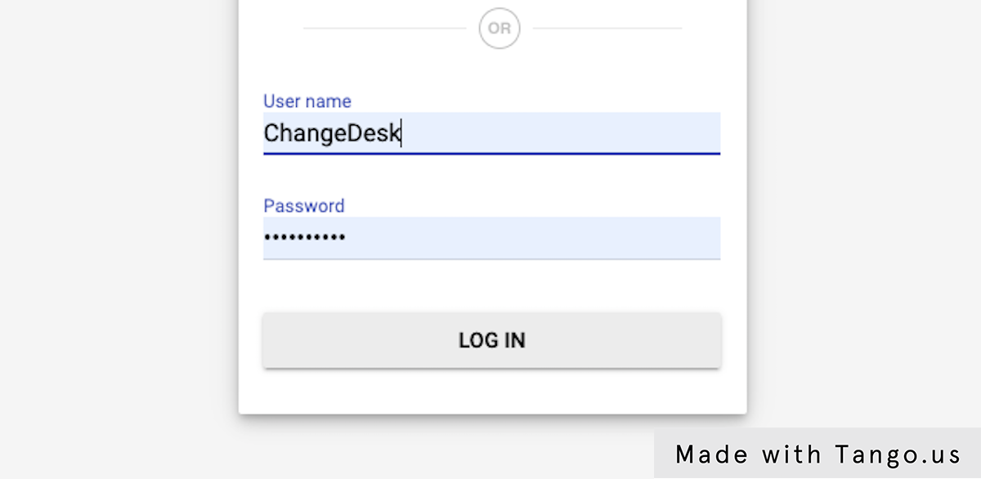

### 4. Click on LOG IN

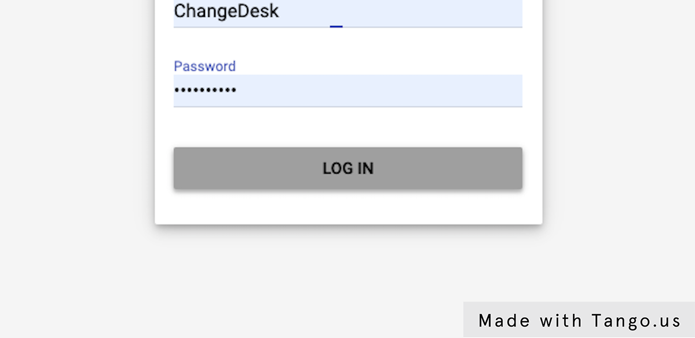

### 5. Click on Gelmaat Masterdata



### 6. Click on Workflows

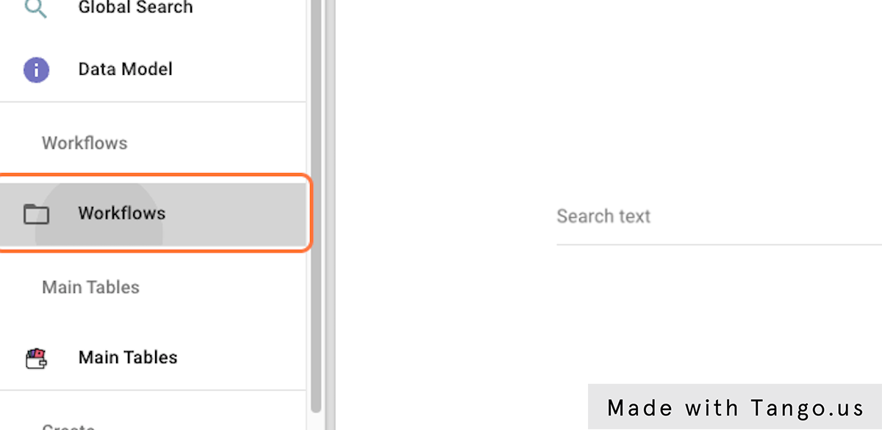

### 7. Click on Deactivate Cash Points

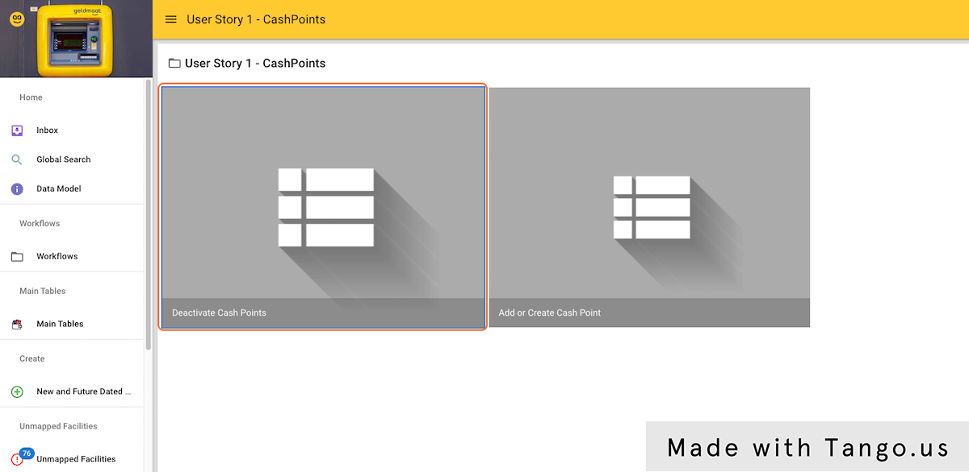

### 8. Select one or multiple Cash Points

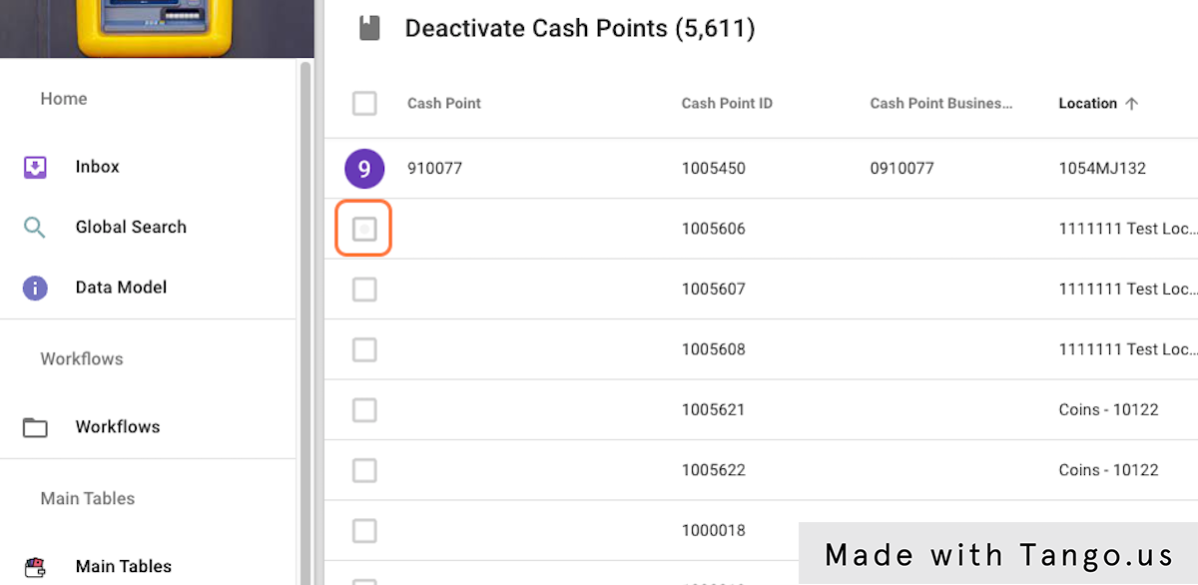

### 9. Select one or multiple Cash Points

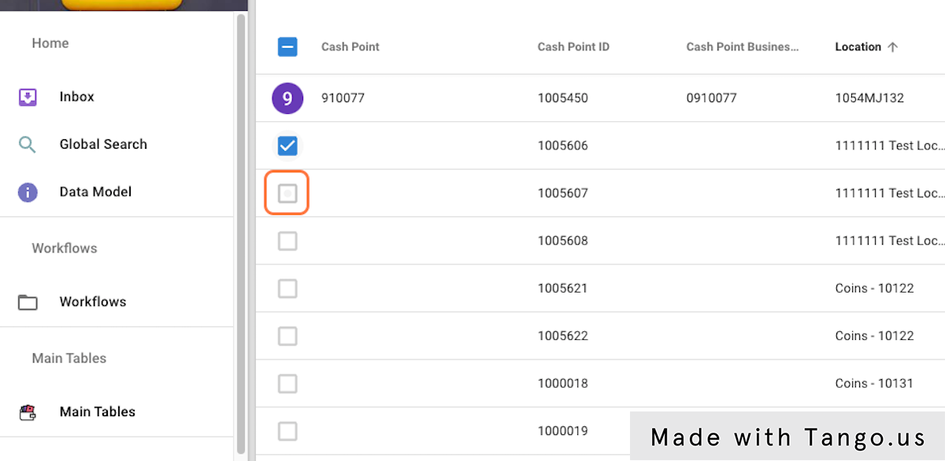

### 10. Select one or multiple Cash Points

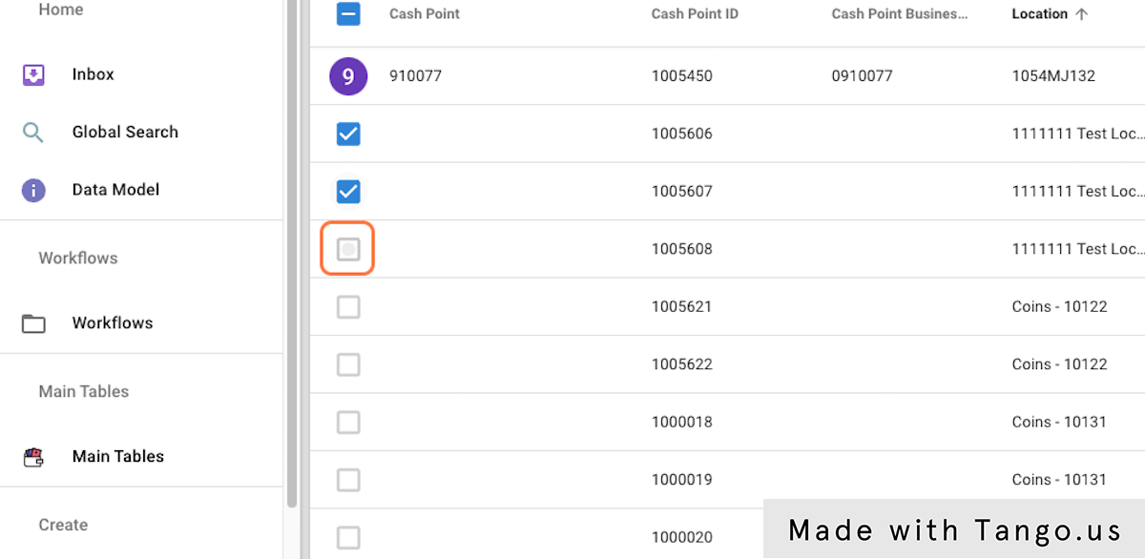

### 11. Click on select the options button

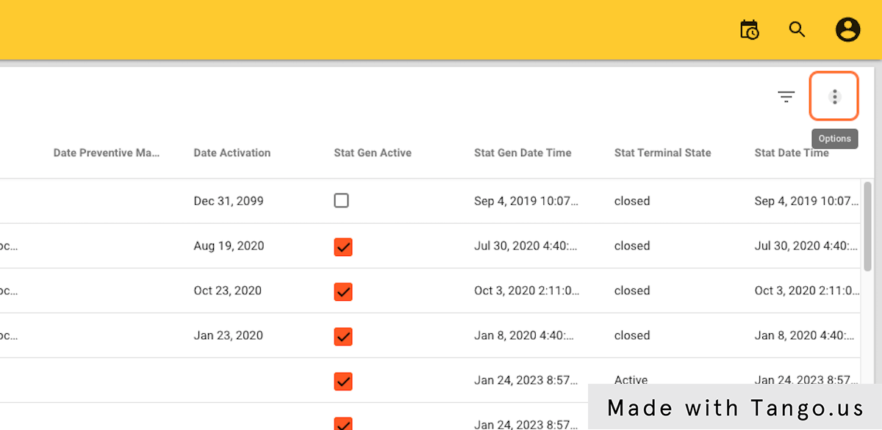

### 12. Click on Update Cash Points

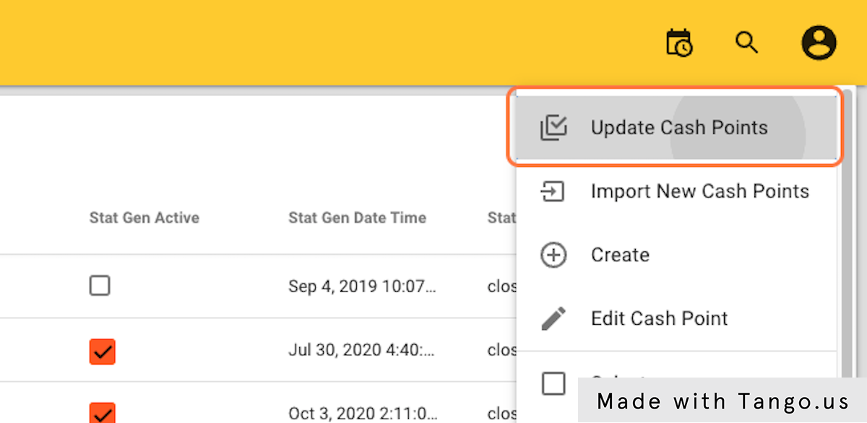

### 13. Click on Update value for EndDate

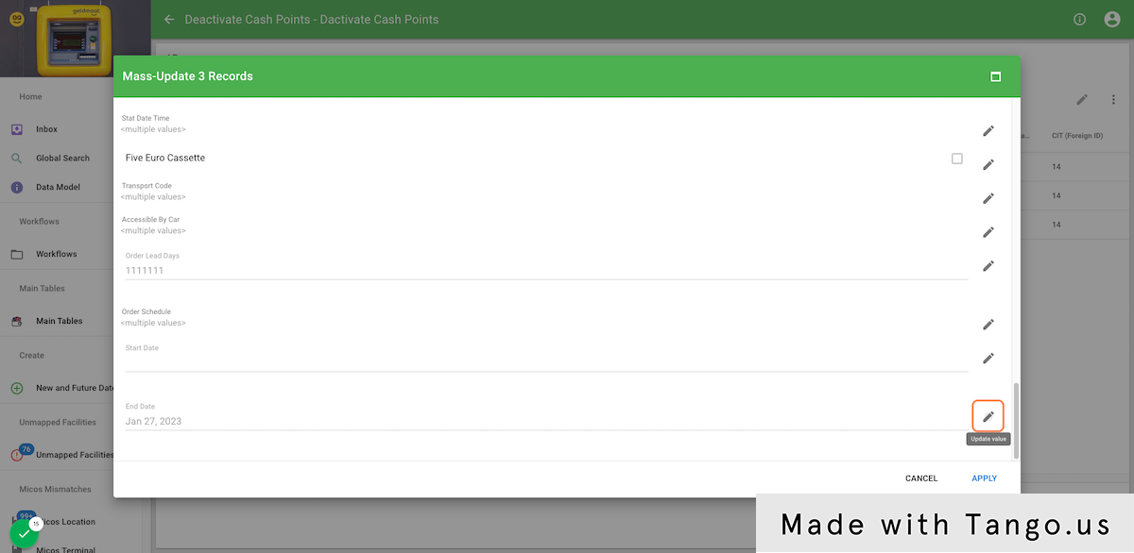

### 14. Click on the date picker

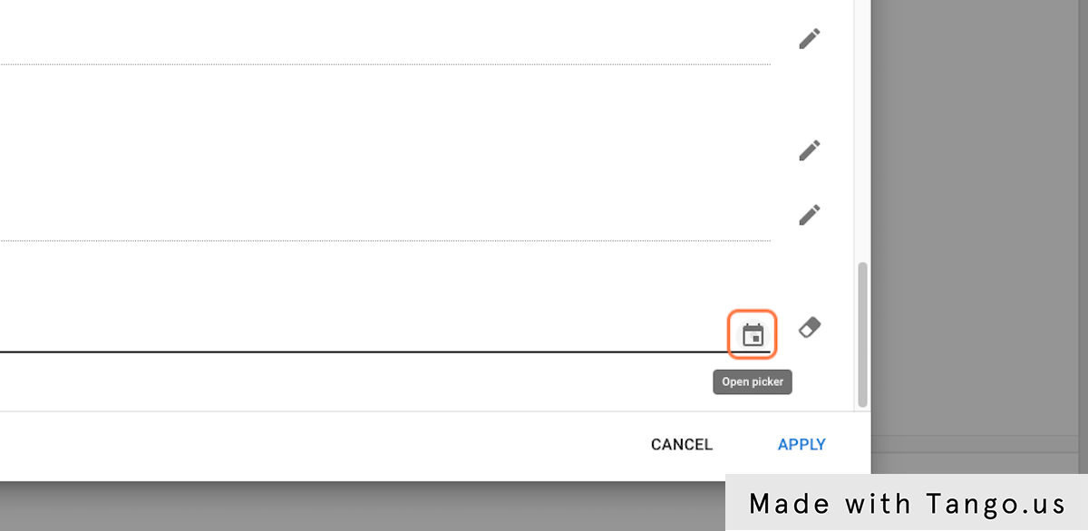

### 15. Select a EndDate

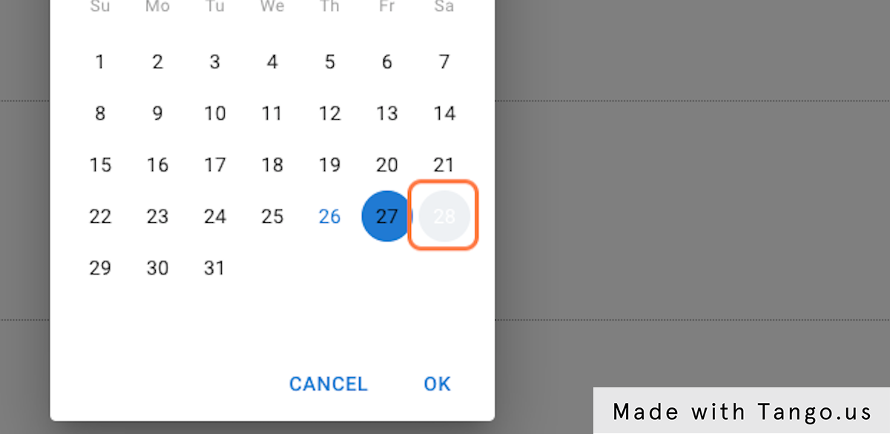

### 16. Click on OK

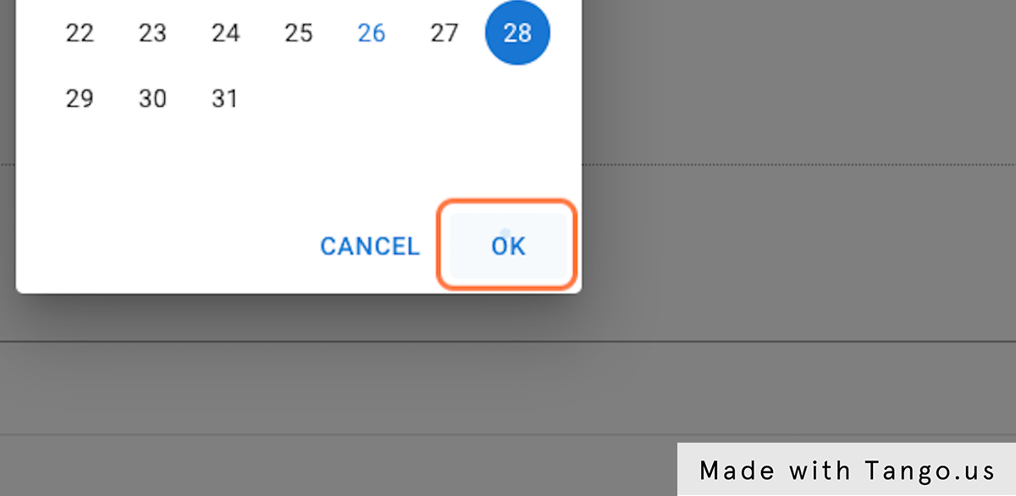

### 17. Click on APPLY

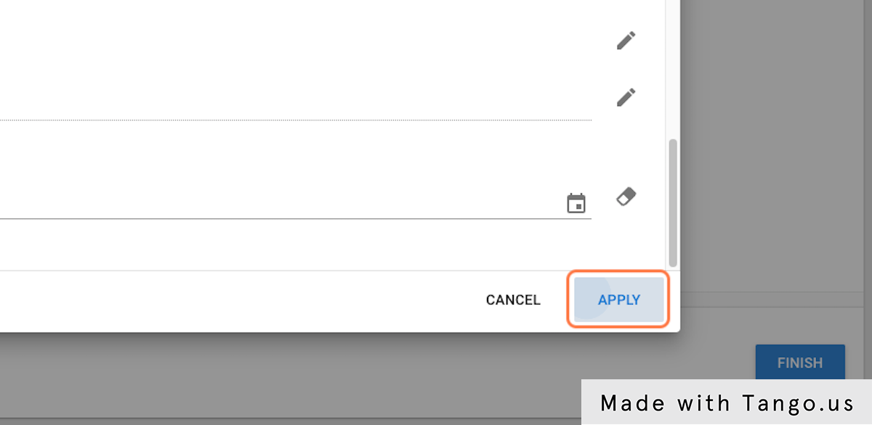

### 18. Click on FINISH

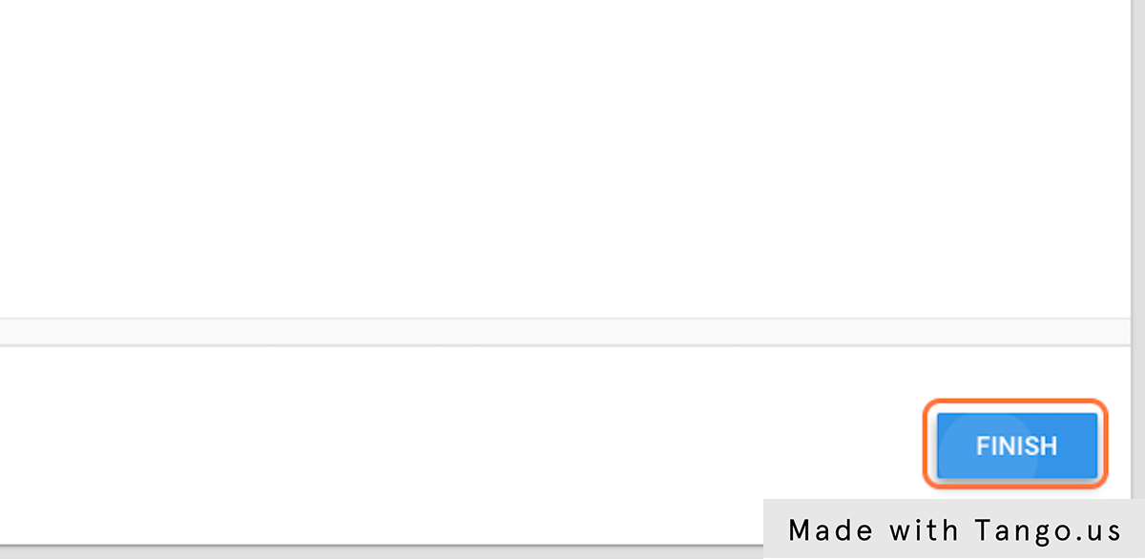

### 19. Click on Deactivate Cash Points To Change Desk Manager

Click on Deactivate Cash Points
          
          
            To Change Desk Manager

### 20. Click on profile image

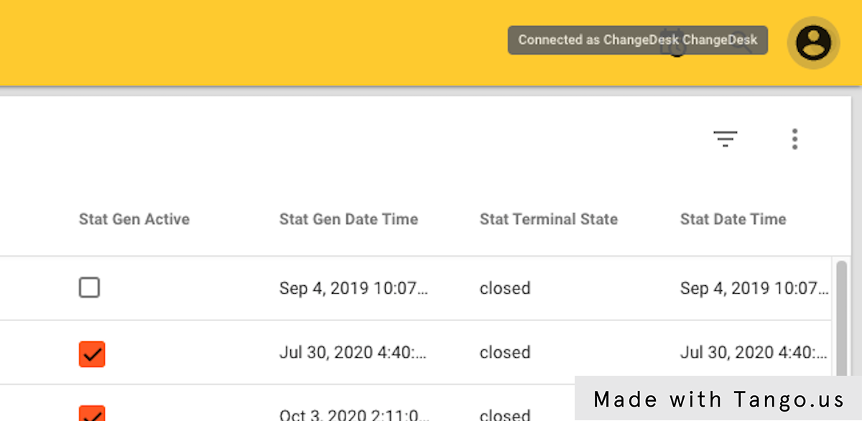

### 21. Click on Logout

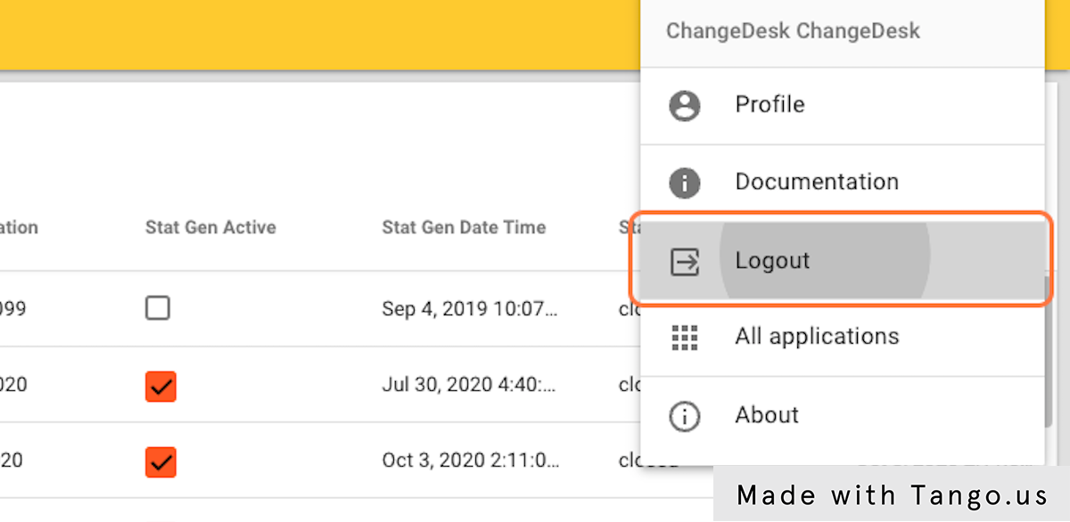

### 22. Next Log in as the Change Desk Manager

### 23. Type "ChangeDeskManager"

### 24. Type password

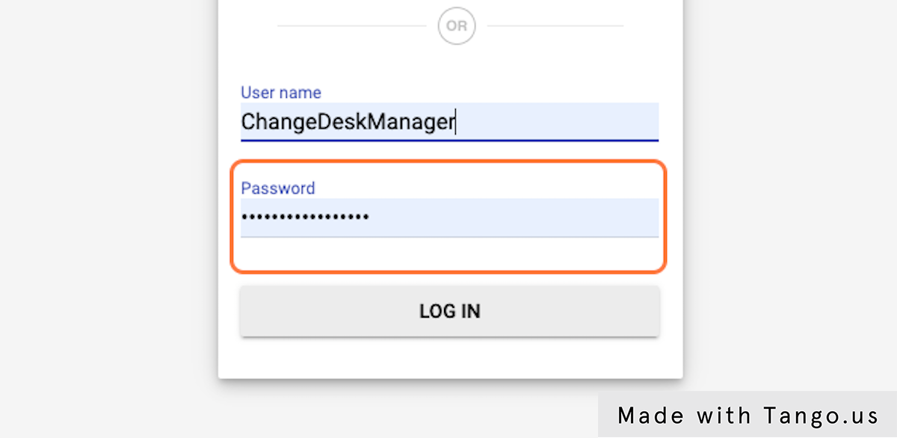

### 25. Click on LOG IN

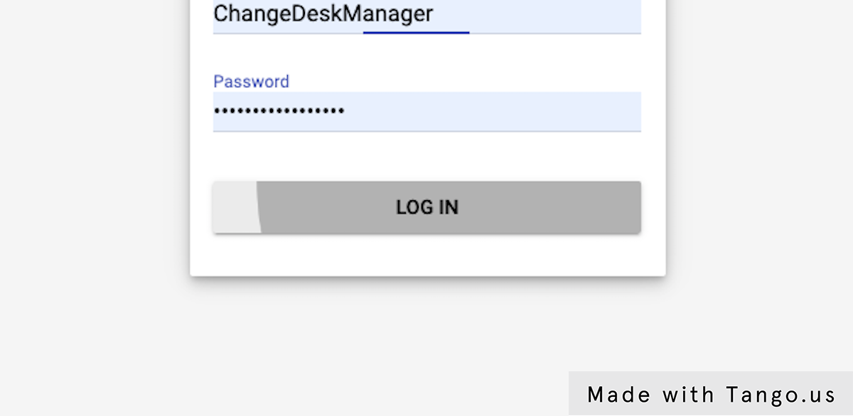

### 26. Click on image



### 27. Click on Inbox

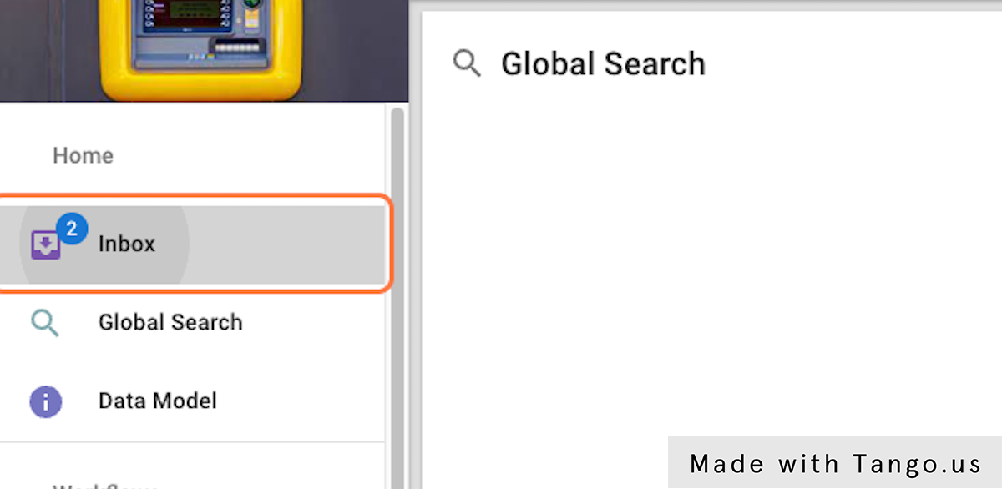

### 28. Click on START

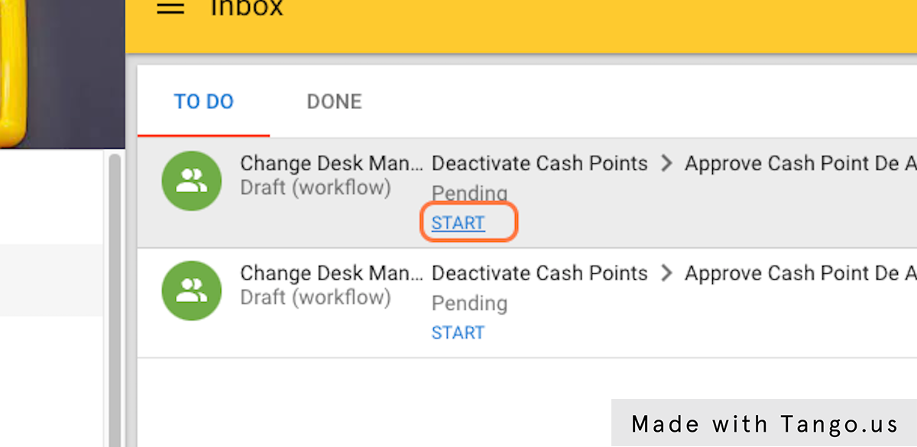

### 29. Drag highlighted element

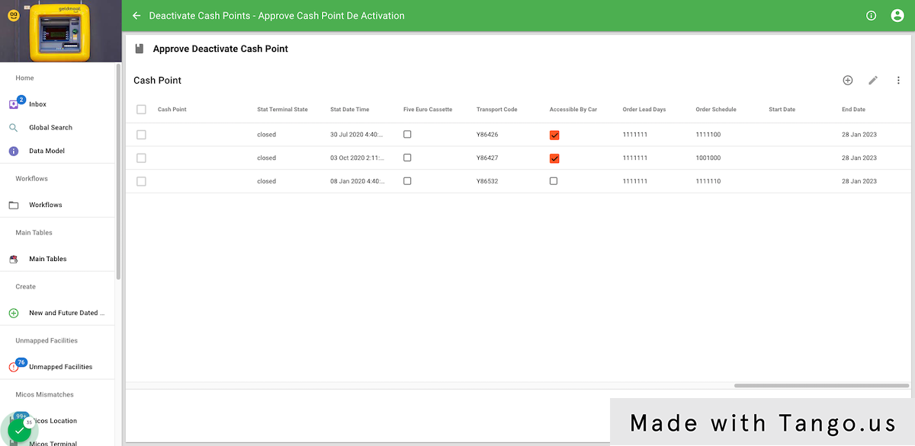

### 30. Click on FINISH

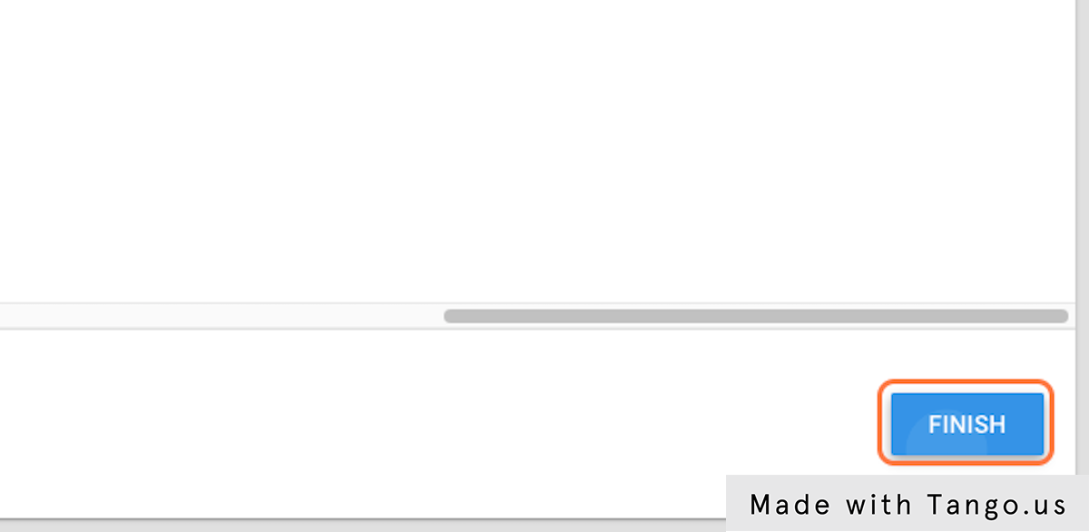

### 31. You can Approve, Reject back to the Change Desk or Outright Reject the change

You can Approve, Reject back to the Change Desk or Outright Reject the change
          
          
            

### 32. Click on OK

